

Assignment No.: 07
Name : Aditya Latke
PRN : 1262252462
DIV : 1

PROBLEM STATEMENT: Write a C program to accept student details and display their result using an array of structures.

OBJECTIVE:

- To understand the concept of structures in C.
- To learn how to store multiple records using an array of structures.
- To accept and process student details such as name, roll number, and marks.
- To calculate total and percentage and display the result.

THEORY:
In C programming, a structure is a user-defined data type that allows grouping of variables of different data types under a single name. When multiple records such as student details need to be stored, an array of structures is used. This allows efficient storage and processing of student information like roll number, name, and marks in different subjects. The program can compute total marks and percentage and display the result for each student.
PLATFORM: Linux

INPUT: Student roll number, name, and marks in three subjects.
#include <stdio.h>
#define MAX 100
struct Student {
char name[50];
int roll;
float marks[3];
float total;
float percentage;
char result[10];
};

int main() {
struct Student s[MAX];
int n, i, j;

printf("Enter number of students: ");
scanf("%d", &n);

// Input student details
for(i = 0; i < n; i++) {
printf("\nEnter details for student %d\n", i + 1);

printf("Name: ");
scanf(" %[^\n]", s[i].name);

printf("Roll Number: ");
scanf("%d", &s[i].roll);

s[i].total = 0;

printf("Enter marks for 3 subjects:\n");
for(j = 0; j < 3; j++) {
printf("Subject %d: ", j + 1);
scanf("%f", &s[i].marks[j]);
s[i].total += s[i].marks[j];
}

s[i].percentage = s[i].total / 3;

// Result calculation
if(s[i].percentage >= 40)
sprintf(s[i].result, "Pass");
else
sprintf(s[i].result, "Fail");
}

// Display results
printf("\n--- Student Results ---\n");

for(i = 0; i < n; i++) {
printf("\nStudent %d\n", i + 1);
printf("Name: %s\n", s[i].name);
printf("Roll Number: %d\n", s[i].roll);
printf("Total Marks: %.2f\n", s[i].total);
printf("Percentage: %.2f%%\n", s[i].percentage);
printf("Result: %s\n", s[i].result);
}
return 0;
}
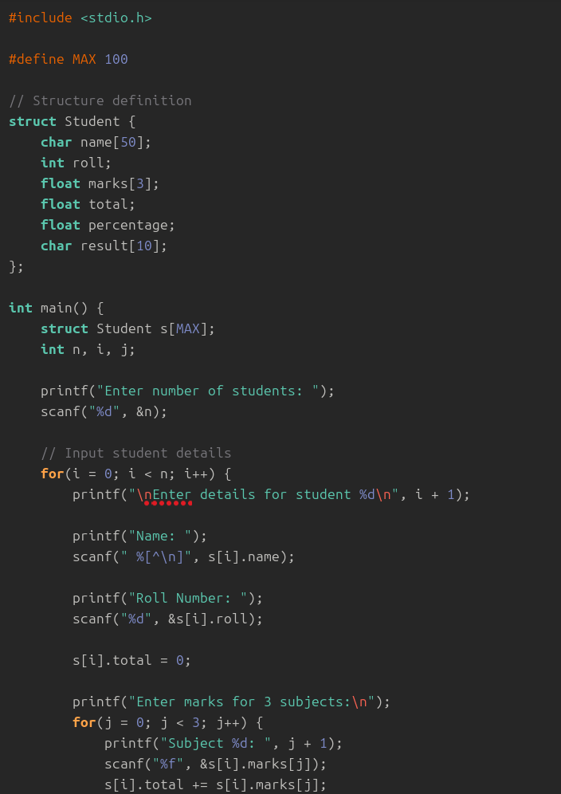
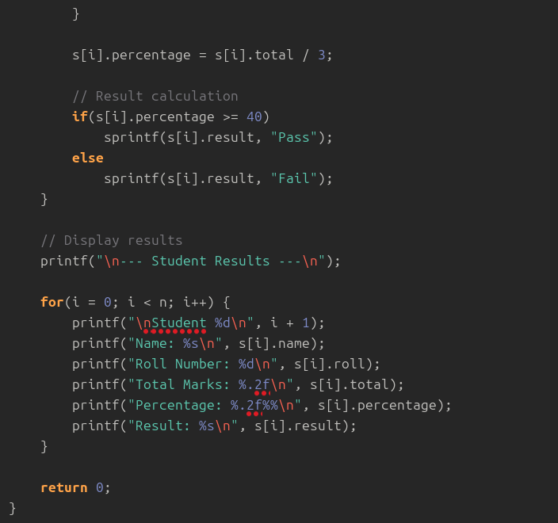

OUTPUT: Displays student details along with total marks and percentage.
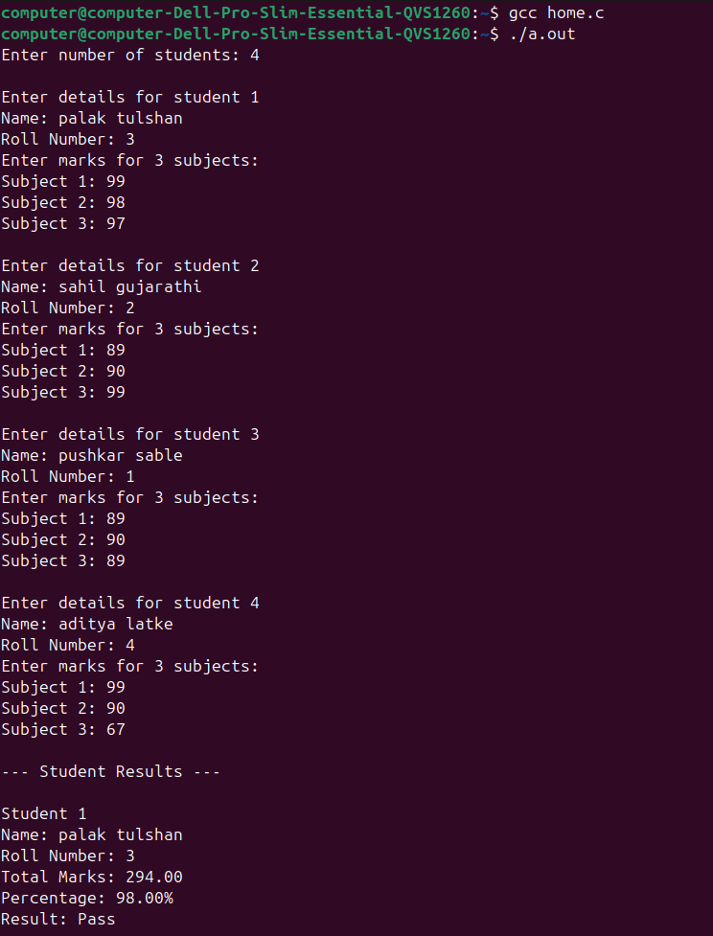

SAMPLE INPUT:
Enter number of students: 1
Roll Number: 101
Name: Rahul
Marks in 3 subjects: 80 75 90

SAMPLE OUTPUT:
Student Result:
Roll No: 101
Name: Rahul
Total Marks: 245
Percentage: 81.67%
CONCLUSION: Thus, the C program successfully accepts student details using an array of structures and displays the calculated result including total marks and percentage.

FAQs:
- What is a structure in C?
- What is the difference between a structure and a union in C?
- What is an array of structures?
- Why are structures used in C programming?
- What is the advantage of using an array of structures?

